Q1)

a)

Graph obtained by plotting the actual curve vs the points predicted by Euler’s first order scheme.

Time, $0≤t≤3$

$$x\left(0\right)={−1}/2$$

$$x\left(t\right)=−t−\frac{1}{e^{t}+1}$$

taking time-steps, h = 0.01

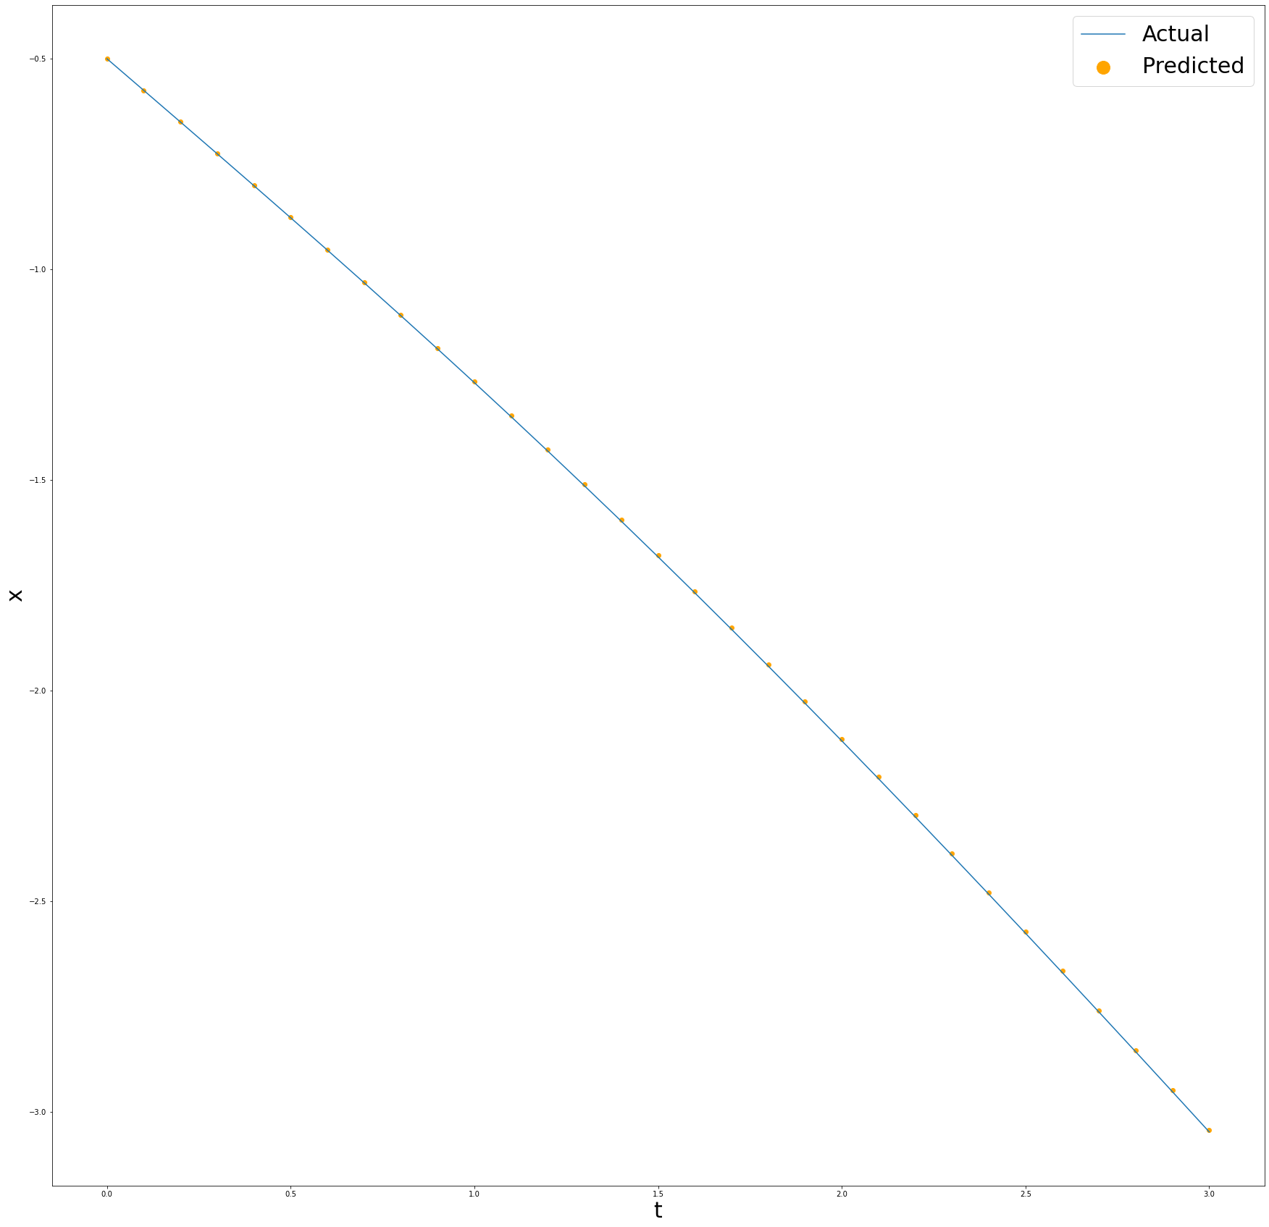

b)

Graph obtained by plotting the actual curve vs the points predicted by Euler’s first order scheme.

Time, $0≤t≤3$

$$x\left(0\right)=−1$$

$$x\left(t\right)=−t−1$$

taking time-steps, h = 0.01

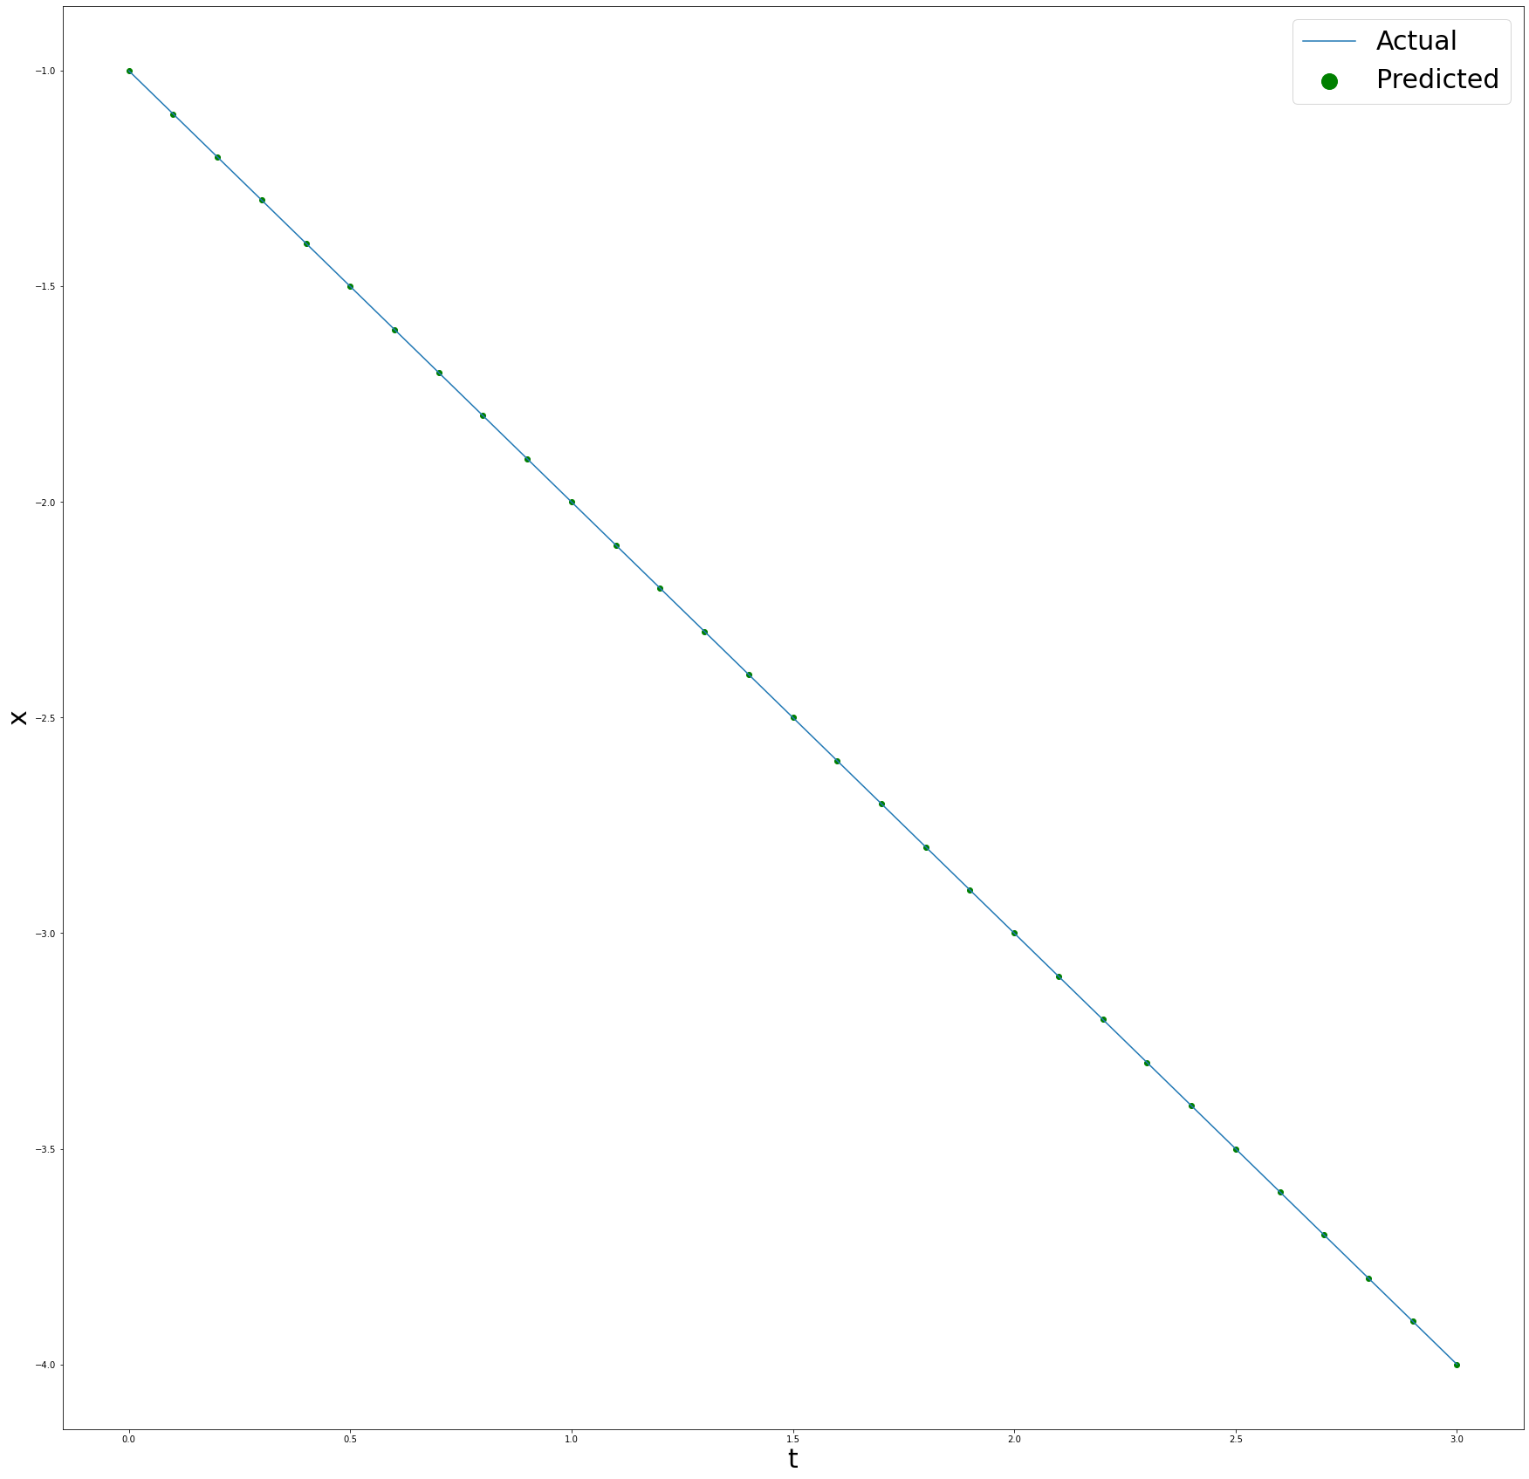

2)

For initial population = 2.44

Graph obtained by plotting the points predicted by Euler’s first order scheme.

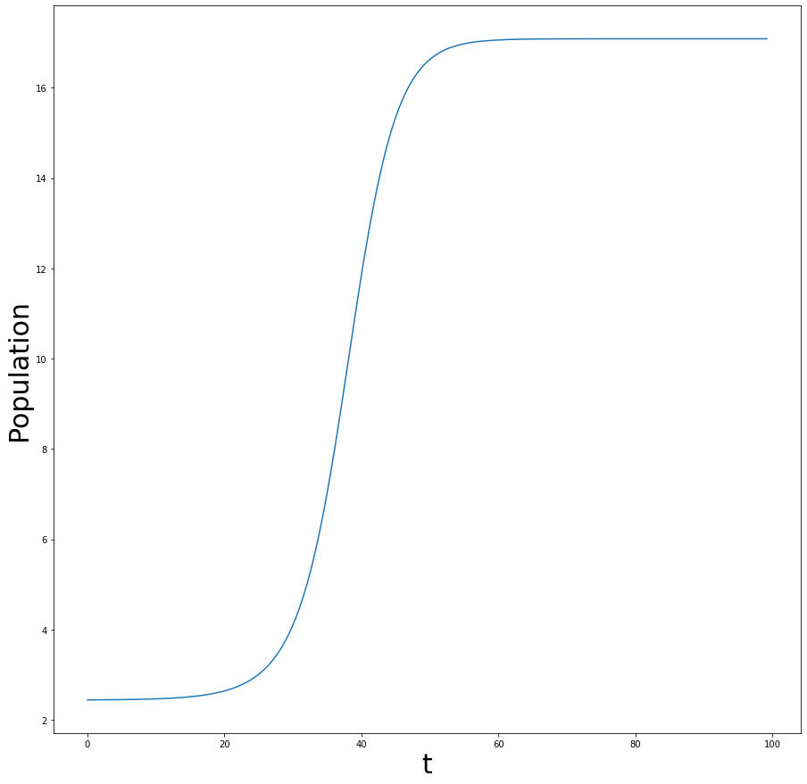

The population increases and eventually converges to 17.0831307

For initial population = 2.40

Graph obtained by plotting the points predicted by Euler’s first order scheme.

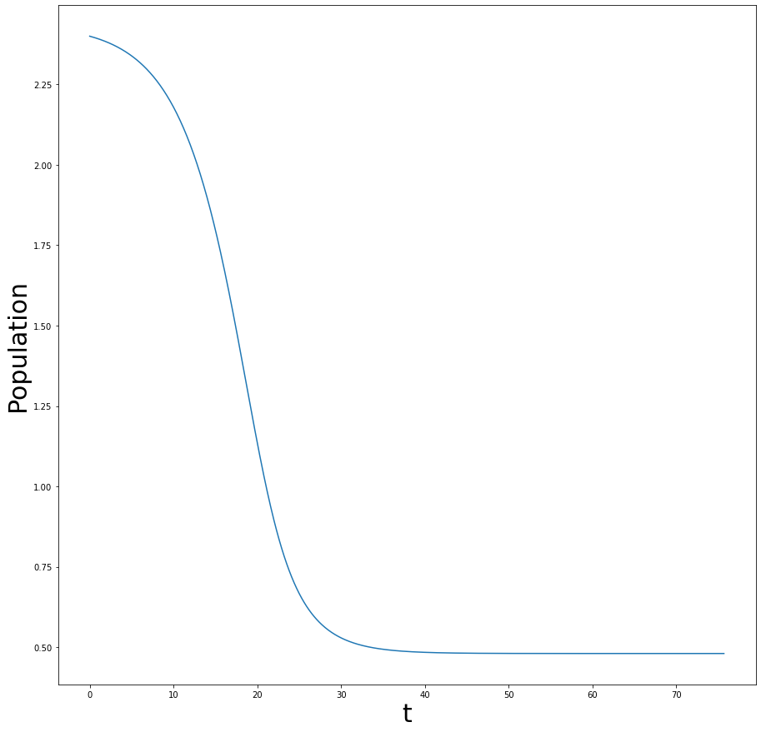

The population decreases and eventually converges to 0.480536317.

3)

For initial temperature = 0 K

Graph obtained by plotting the points predicted by RK - 4 scheme.

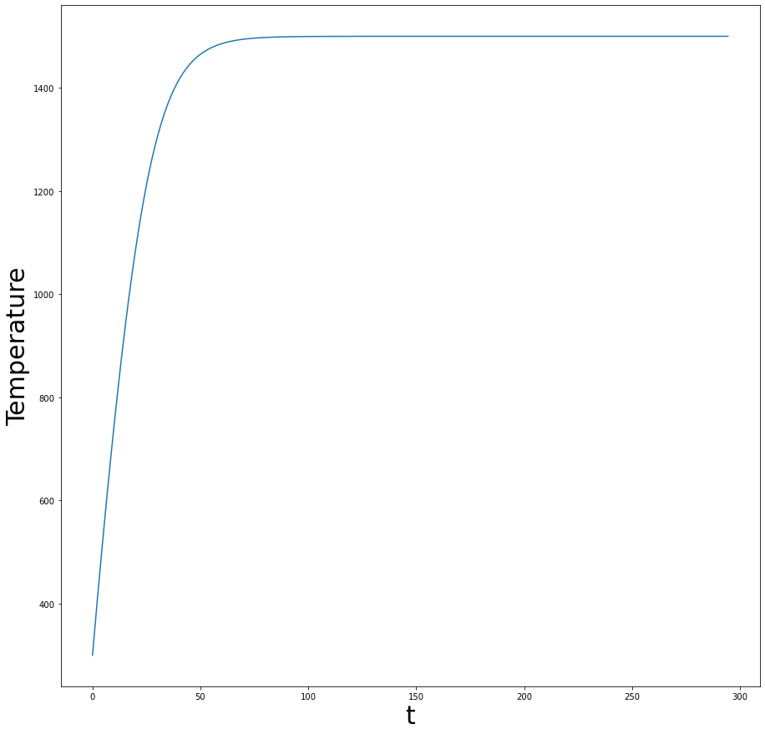

Time taken, t = 294.4 s

4)

Using RK-2:

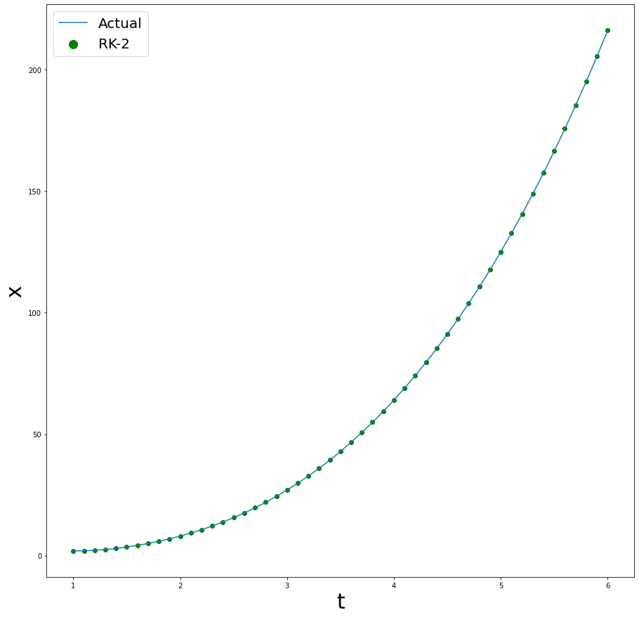

Taking time-steps of size 0.1, we get a percentage error of -0.03720518543% with RK-2.

Using RK-4:

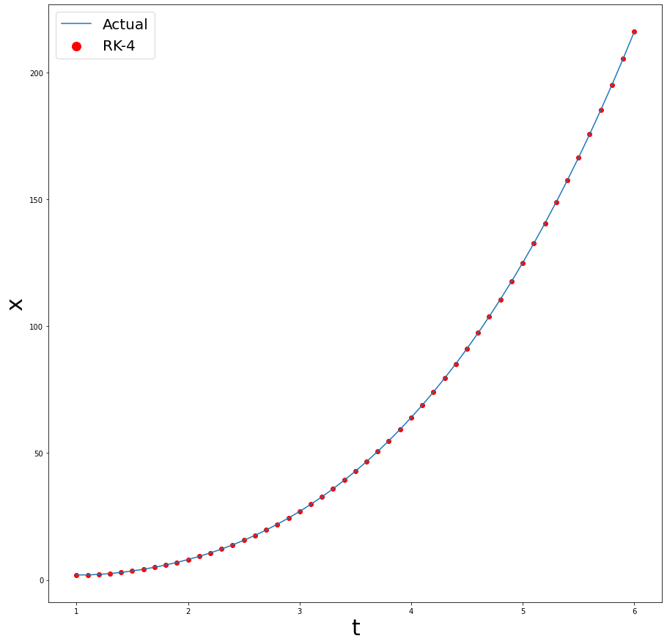

Taking the same time-steps of size 0.1, we get a percentage error of -8.66159974e-06% with RK-4.

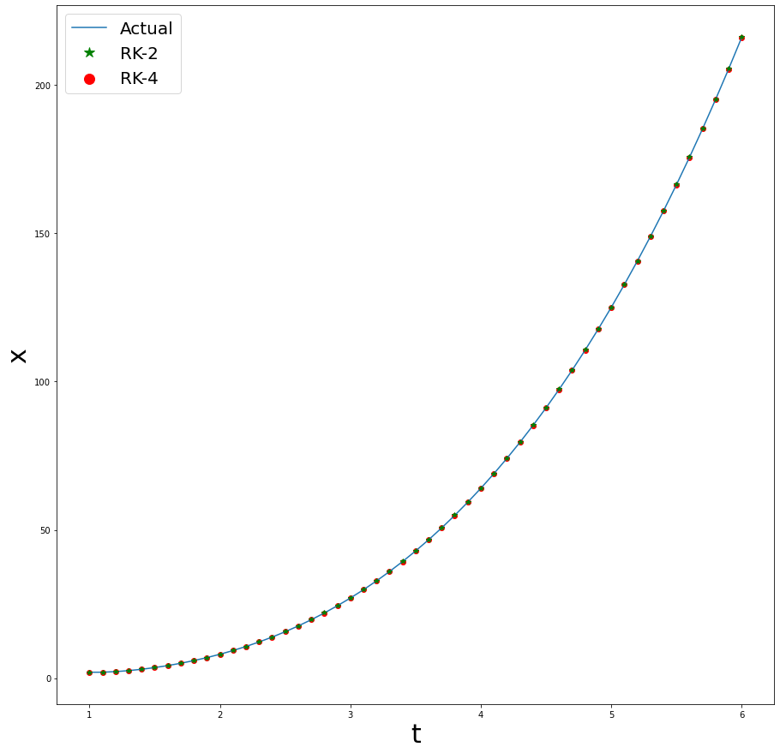

Hence, we can see that RK-4 converges much faster in the same number of iterations.

5)

Using RK-2:

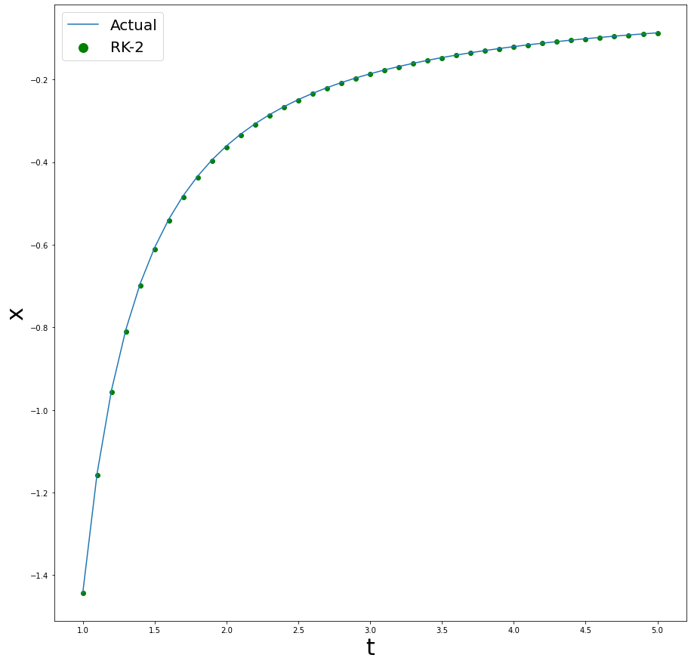

Taking time-steps of size 0.1, we get a percentage error of -0.5357938563% with RK-2.

Using ABM-2:

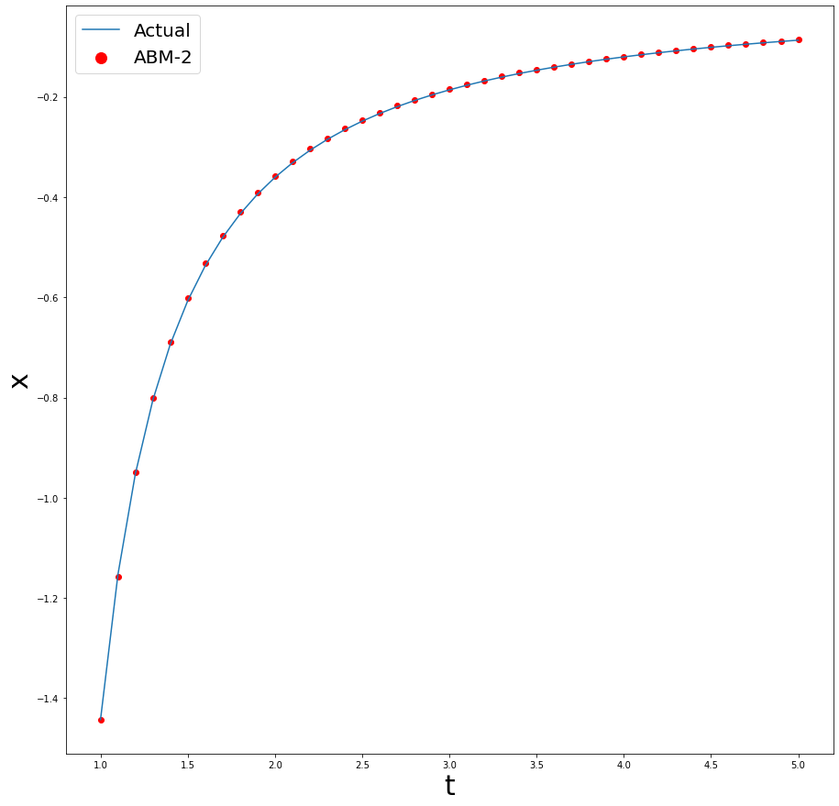

Taking the same time-steps of size 0.1, we get a percentage error of 0.7384963899% with ABM-2.

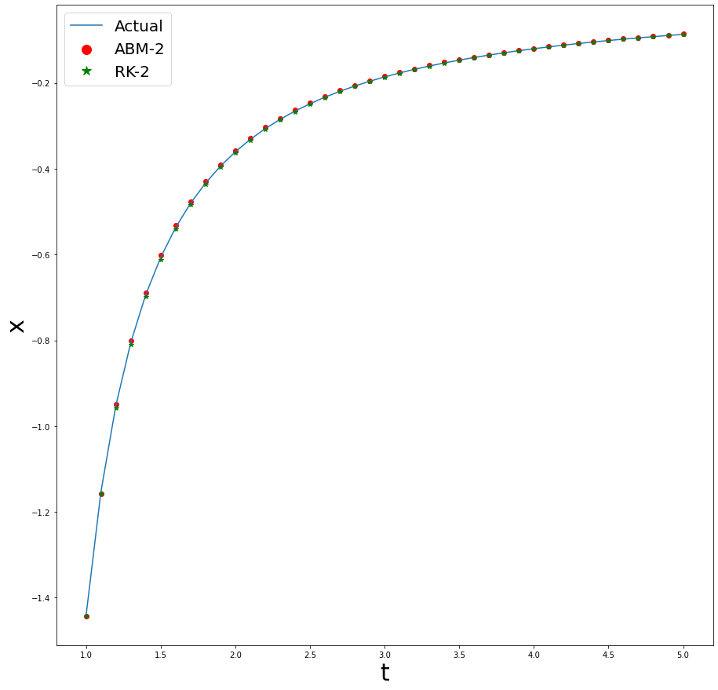

Hence, we can conclude that RK-2 has better convergence than ABM-2 for same time-steps.

6)

Using RK-4:

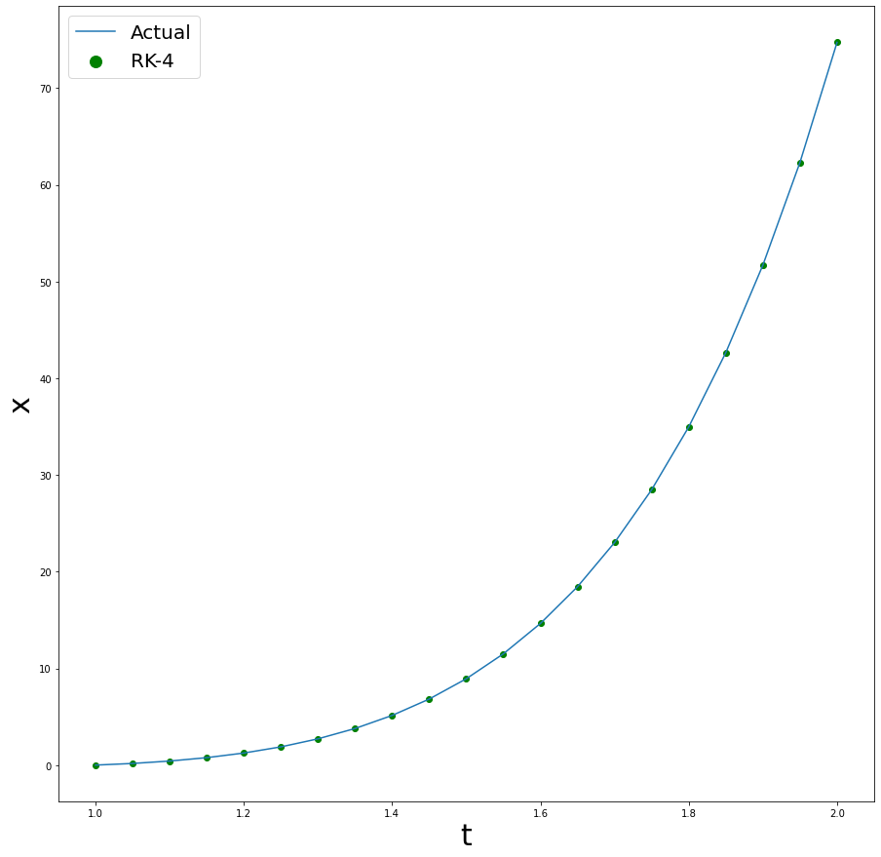

Taking time-steps of size 0.05, we get a percentage error of 0.0008569493606% with RK-4.

Using ABM-4:

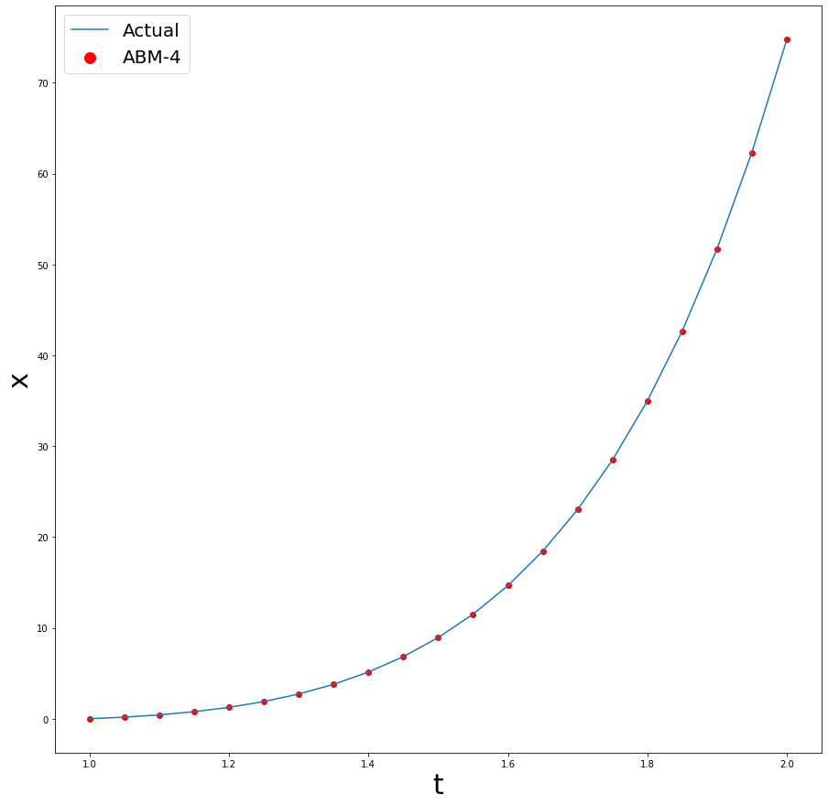

Taking the same time-steps of size 0.05, we get a percentage error of -0.0005567053846% with ABM-4.

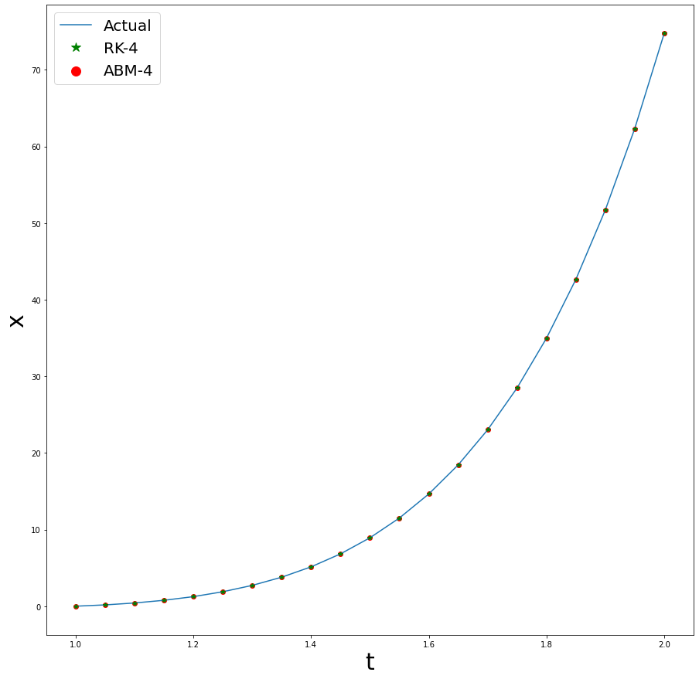

Hence, we can conclude that ABM-4 has better convergence than RK-4 for same time-steps.

7)

$$X''+\left(X^{2}−1\right)+X=0$$

$$puttingU_{1}=X,U_{2}=X',weget:$$

$U_{1}'=U_{2}$--(1)

$U_{2}'+\left(U_{1}^{2}−1\right)∗U_{2}+U_{1}=0$--(2)

Taking time-steps, h = 0.1

Solving (1) and (2) simultaneously using RK-4, we get the following curve:

